Name-Saiba pathan
Rollno-09
Div-C
Lab 12B

Title: Deploying a Network Load Balancer with EC2 Targets

Objective
To deploy a Network Load Balancer (NLB) that distributes traffic across two EC2 instances, each running an Apache web server with a custom webpage. The traffic should be load-balanced in a round-robin manner.

Prerequisites
- AWS Free Tier account
- IAM user with EC2 and ELB permissions
- AWS region: ap-south-1 (Mumbai) or your preferred region
- Key pair for SSH (or use EC2 Instance Connect)

Part A: Launch EC2 Instances
- Go to EC2 > Launch Instances
- Launch two instances:
  - Name: WebServer1, WebServer2
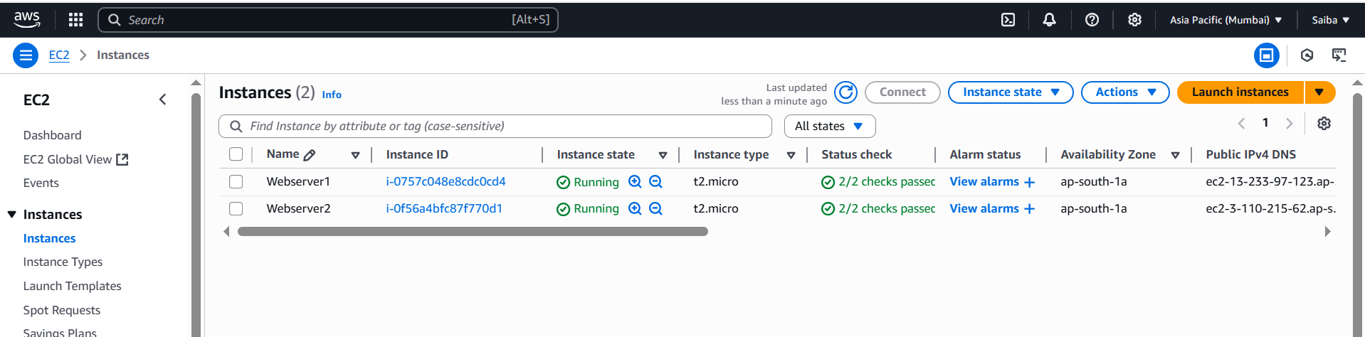

Part B: Configure Web Servers
SSH into both instances using EC2 Instance Connect or SSH, then run the following on each:
sudo yum update -y sudo yum install httpd -y sudo systemctl start httpd sudo systemctl enable httpd
Now create a custom index.html file.
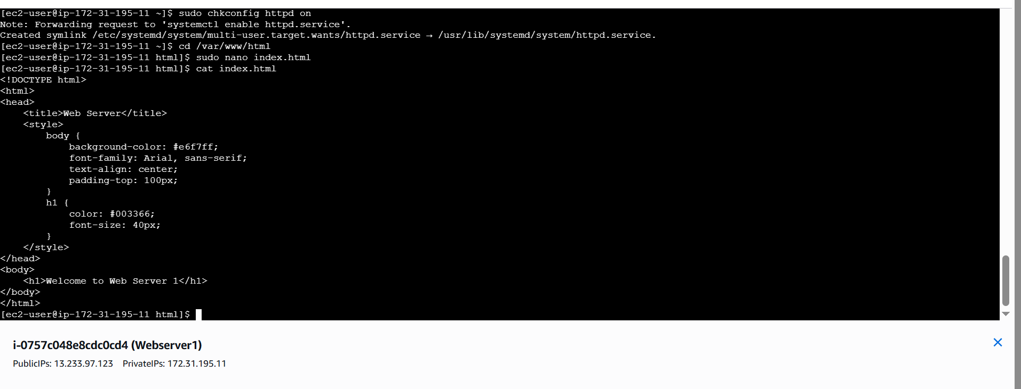
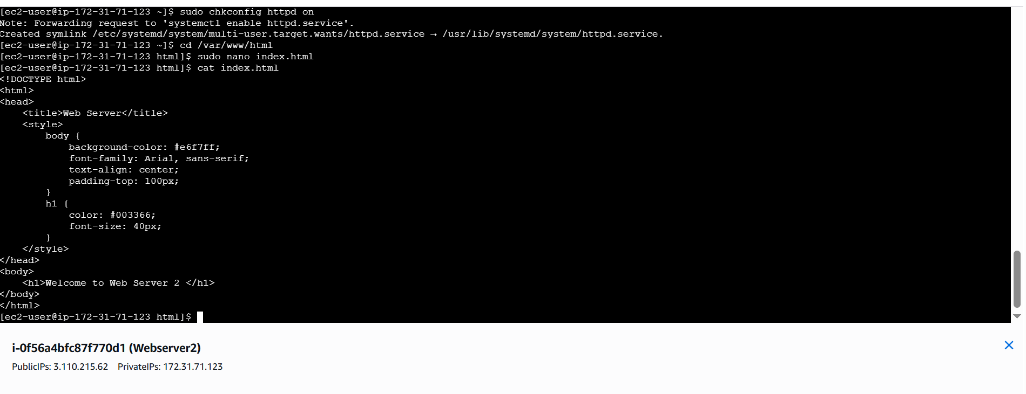
Test from browser:
- http://<PublicIP-of-WebServer1>

- http://<PublicIP-of-WebServer2>
- 

Part C: Create Target Group
- Go to EC2 > Target Groups
- Click Create target group
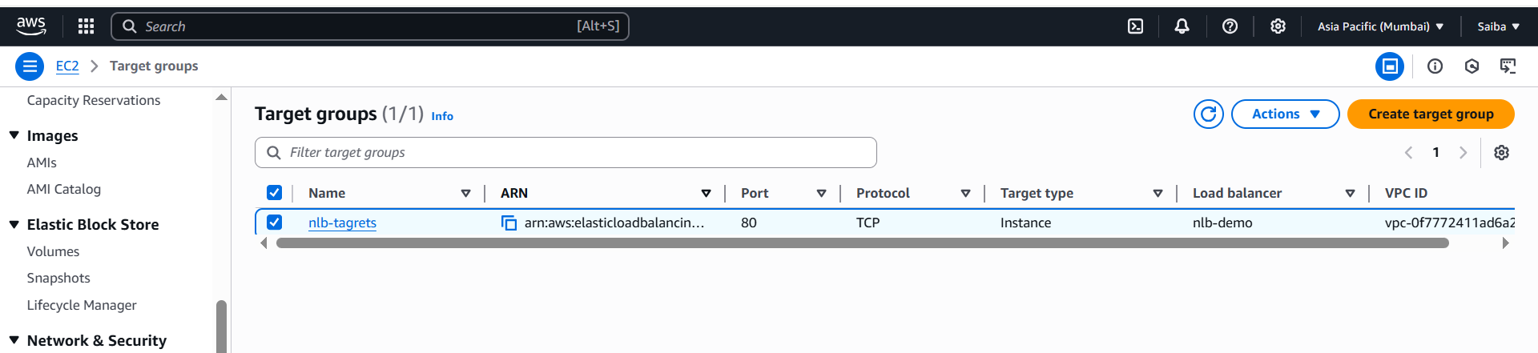

Part D: Create Network Load Balancer
- Go to EC2 > Load Balancers > Create Load Balancer
- Choose Network Load Balancer
- Name: nlb-demo
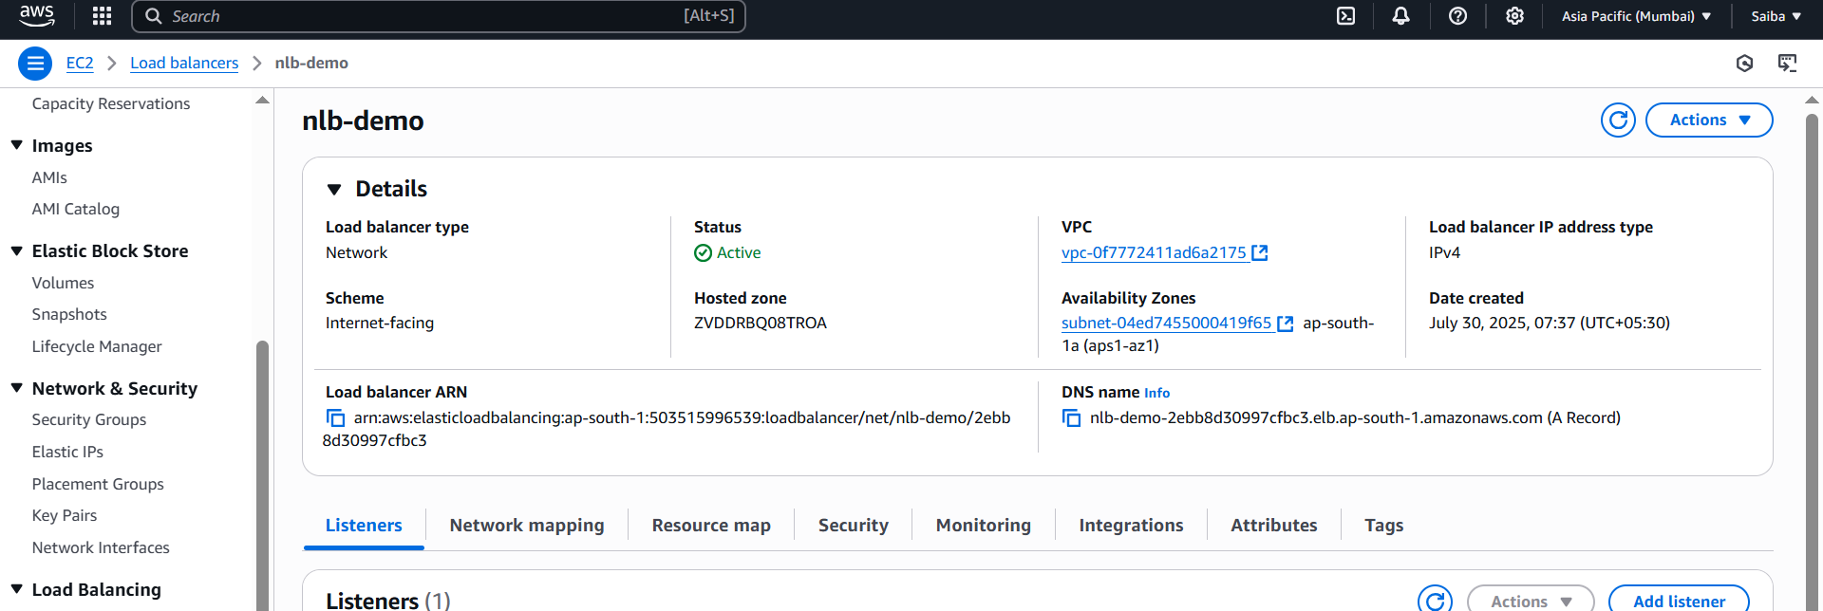

Part E: Test the Load Balancer
- Go to EC2 > Load Balancers • Copy the DNS name of the NLB
- Open it in your browser:
http://<NLB-DNS>
- Refresh the page multiple times, and you should see output alternating between:
- "Welcome to Web Server 1"
- "Welcome to Web Server 2" Round-robin load balancing is working!
- 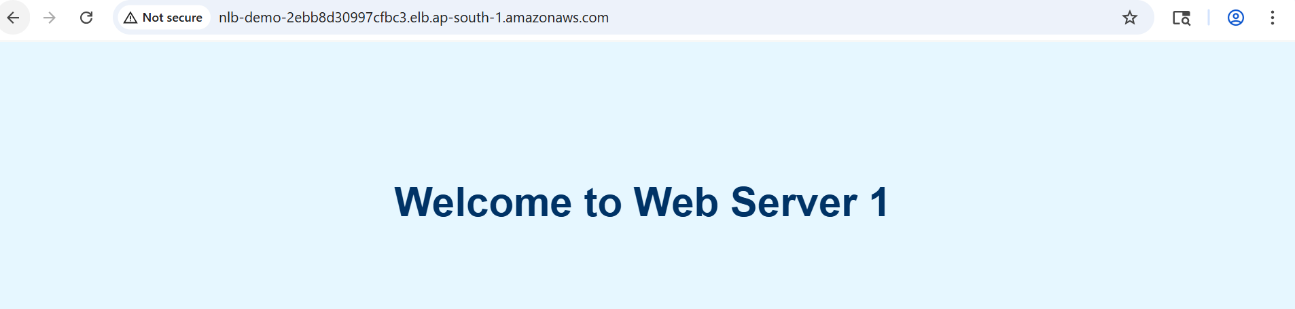
- 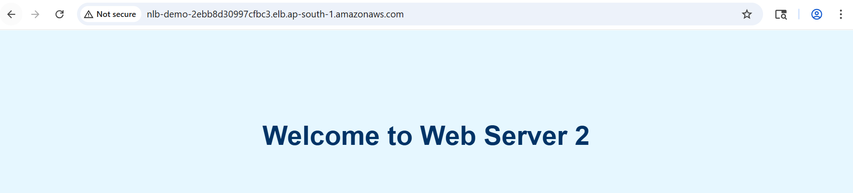

Cleanup (Optional)
To avoid ongoing costs:
- Terminate EC2 instances
- Delete NLB and target group
- Delete security groups if created manually


